|  |
| --- |
| Lab work-03: Full web page design. **Course Tittle: Web Database Programming.**  **Course Code: SE 408** |
|  |

**Lab Work**

|  |  |
| --- | --- |
| **To** | **Md. Sahabuddin Johny** |

**Lecturer, Department of CSE**

**City University, BD**

**From: MD. RAFIUJJAMAN RASEL**

Department of CSE

ID: 1834902039

Batch: 49th

Section: A

Submission date: 25.12.2021

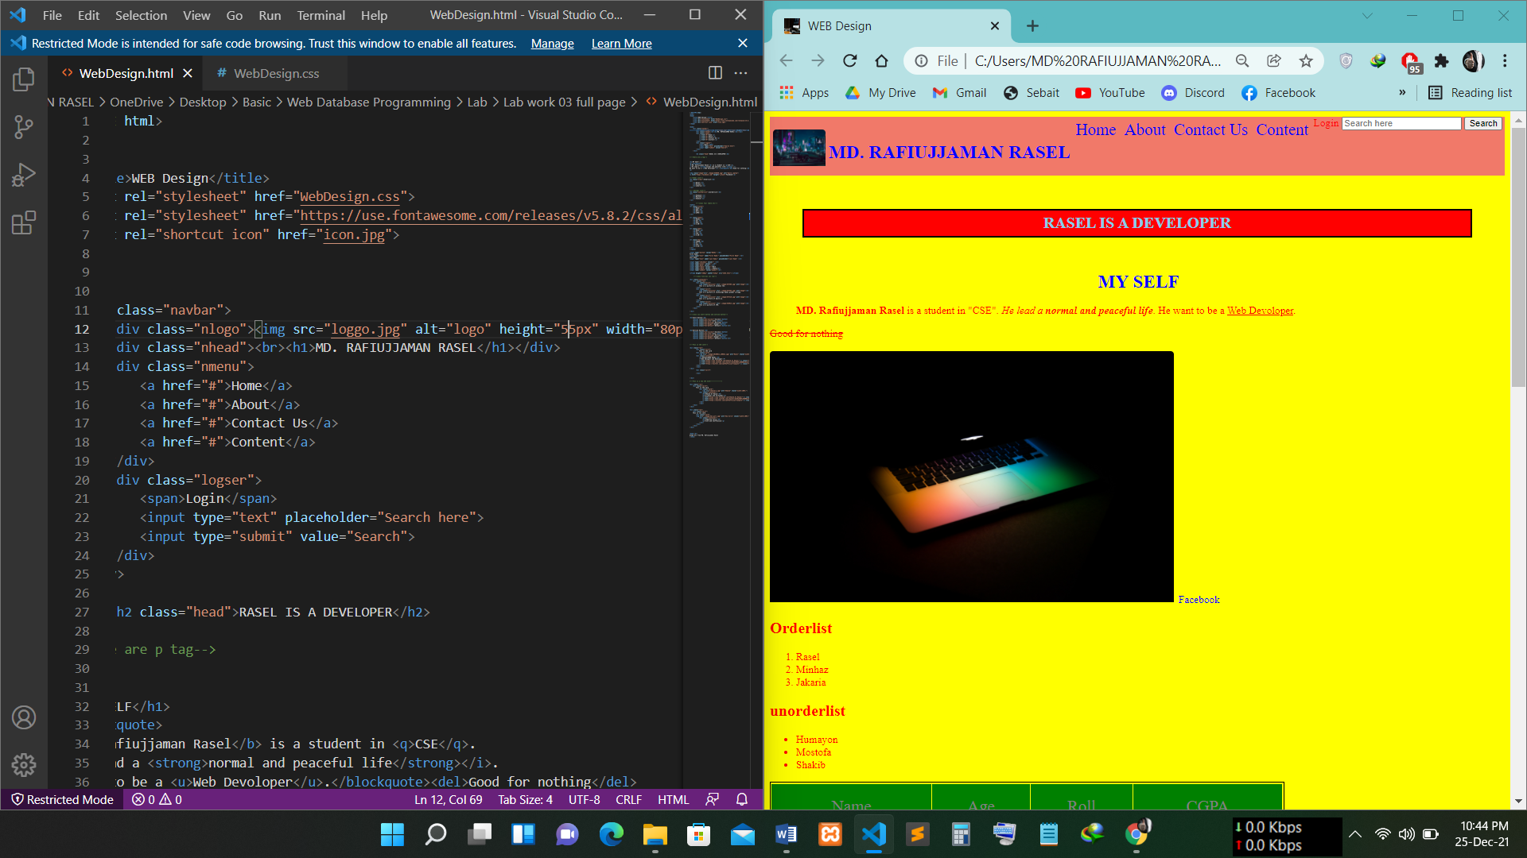

Navigation bar desing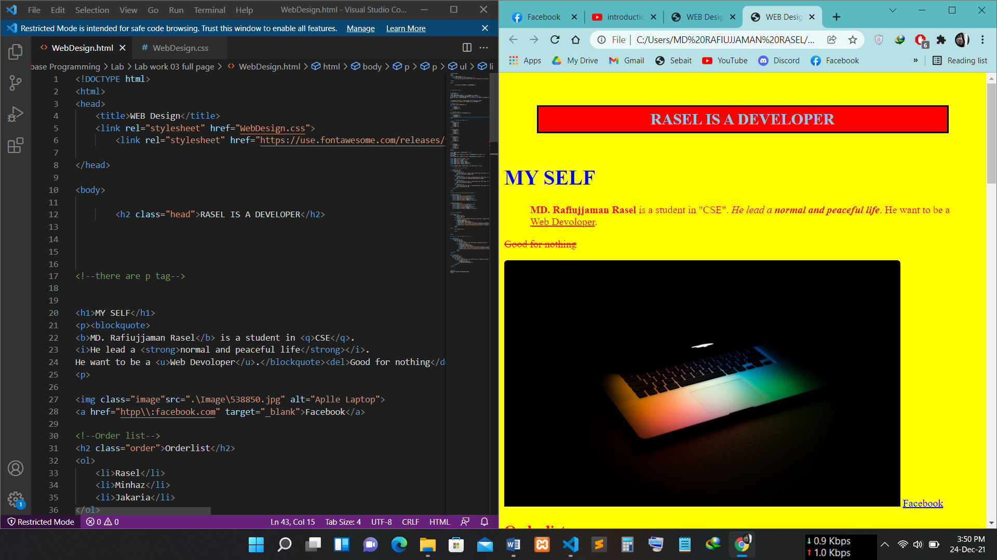

Heading about myself.

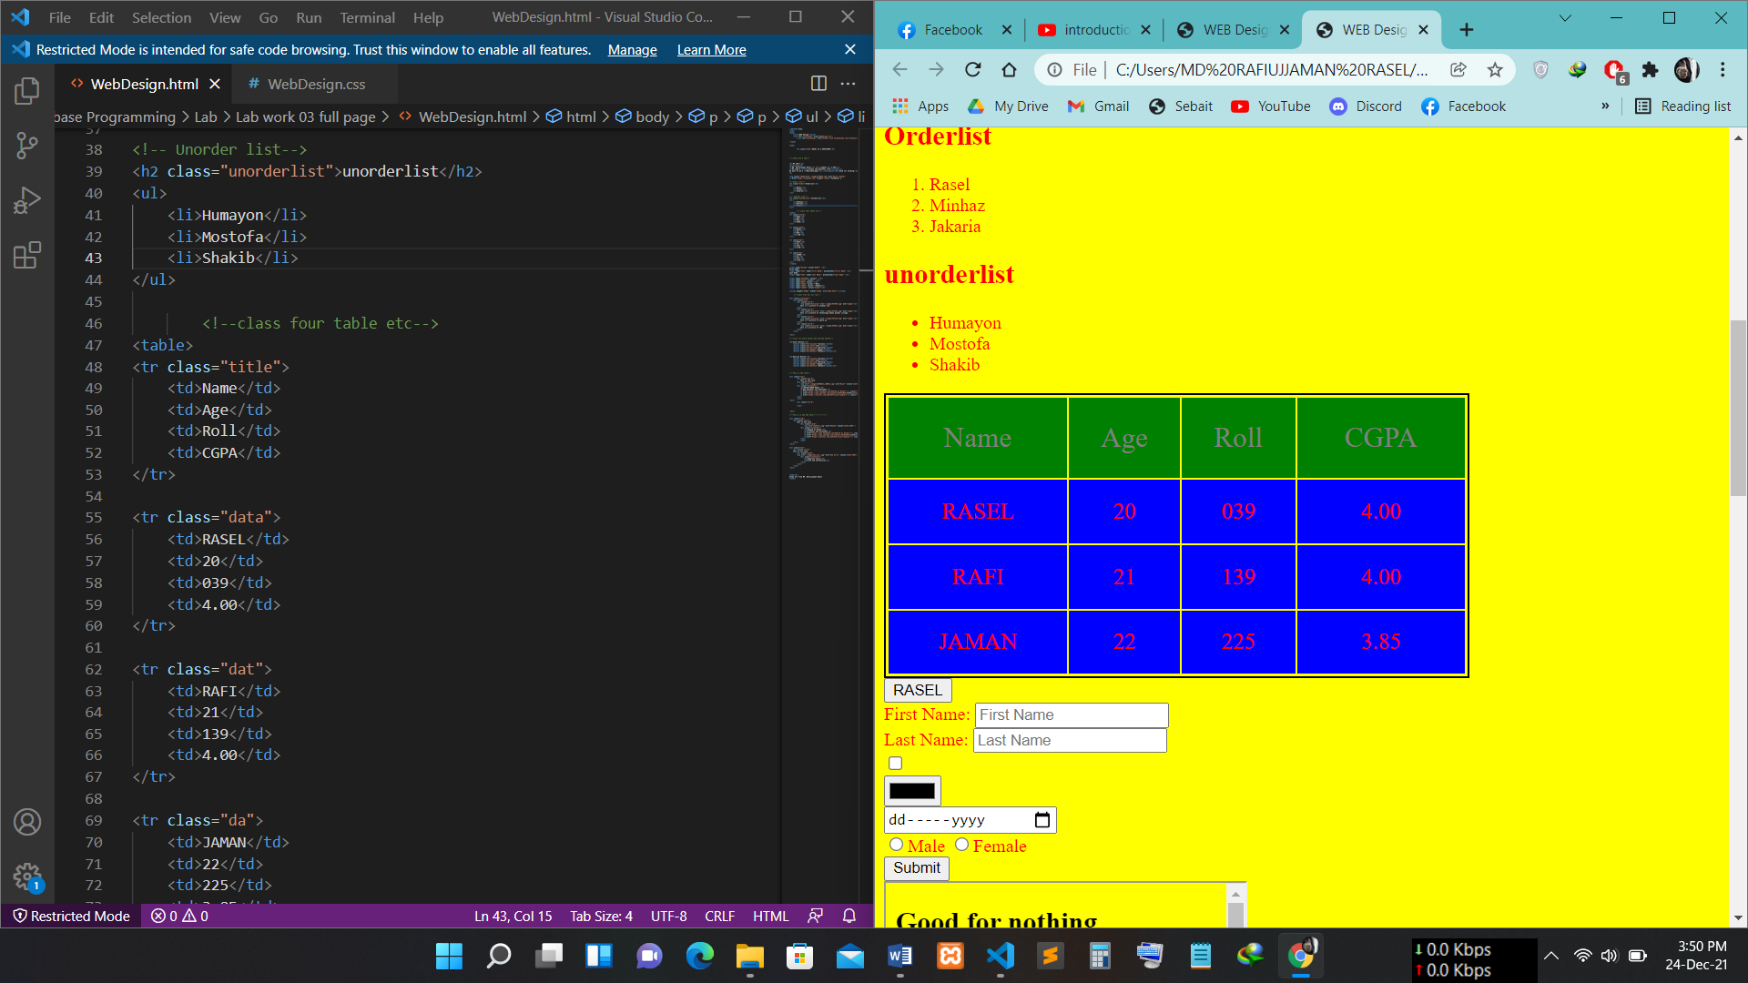

Create a order and unorder list.

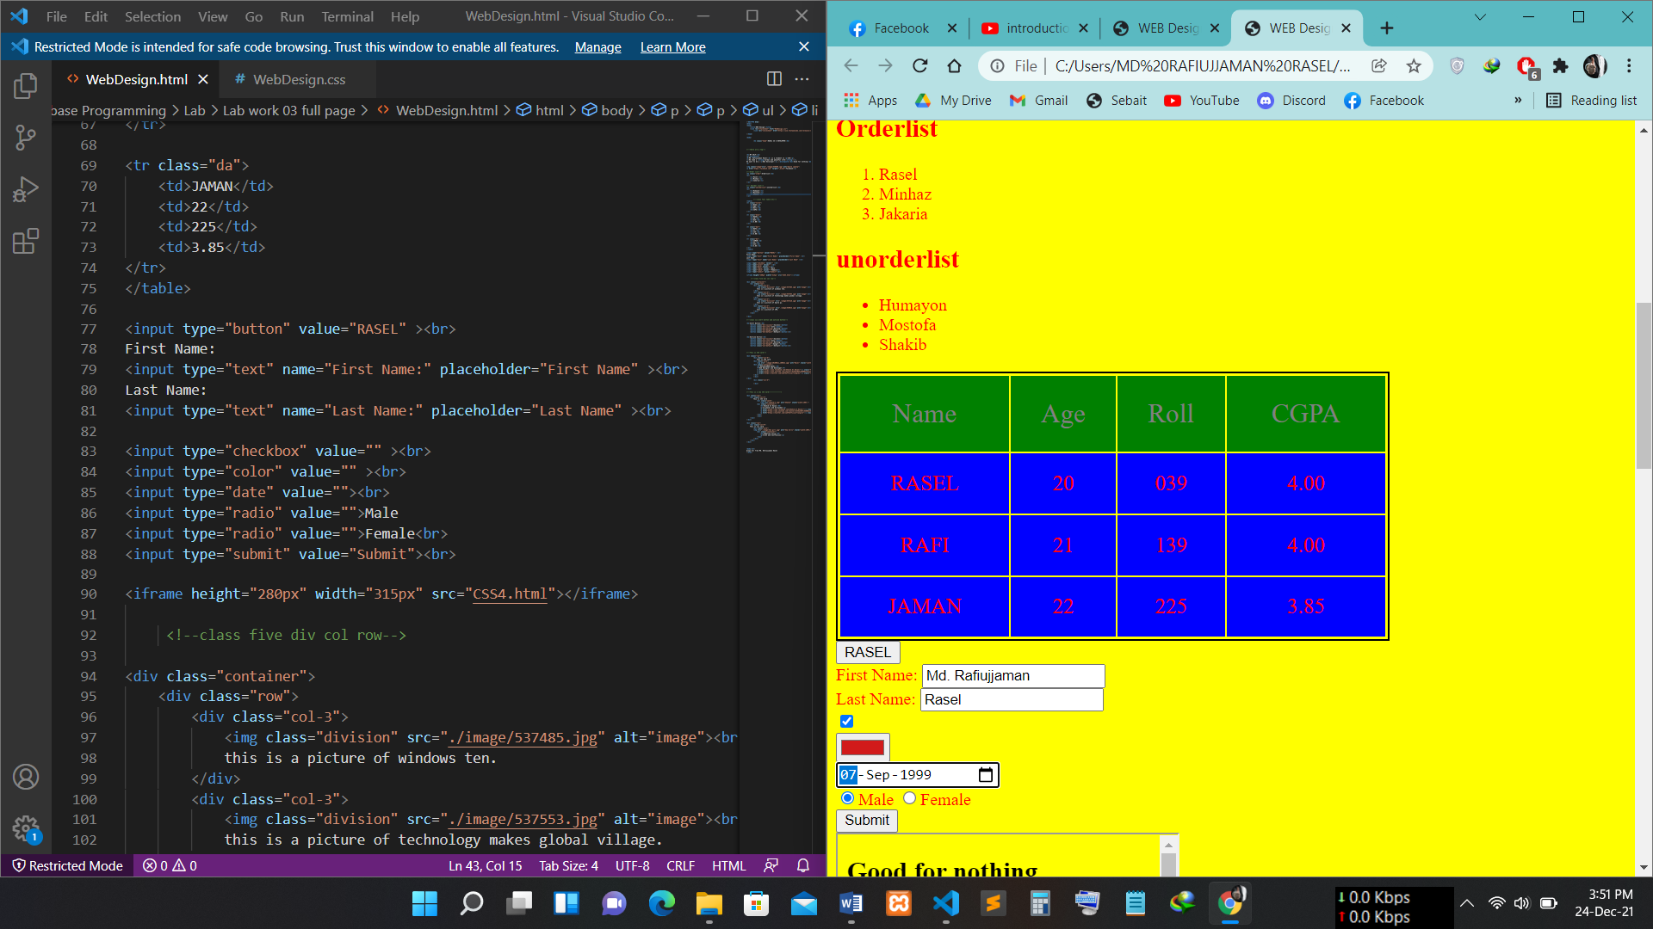

Create a table and some information box.

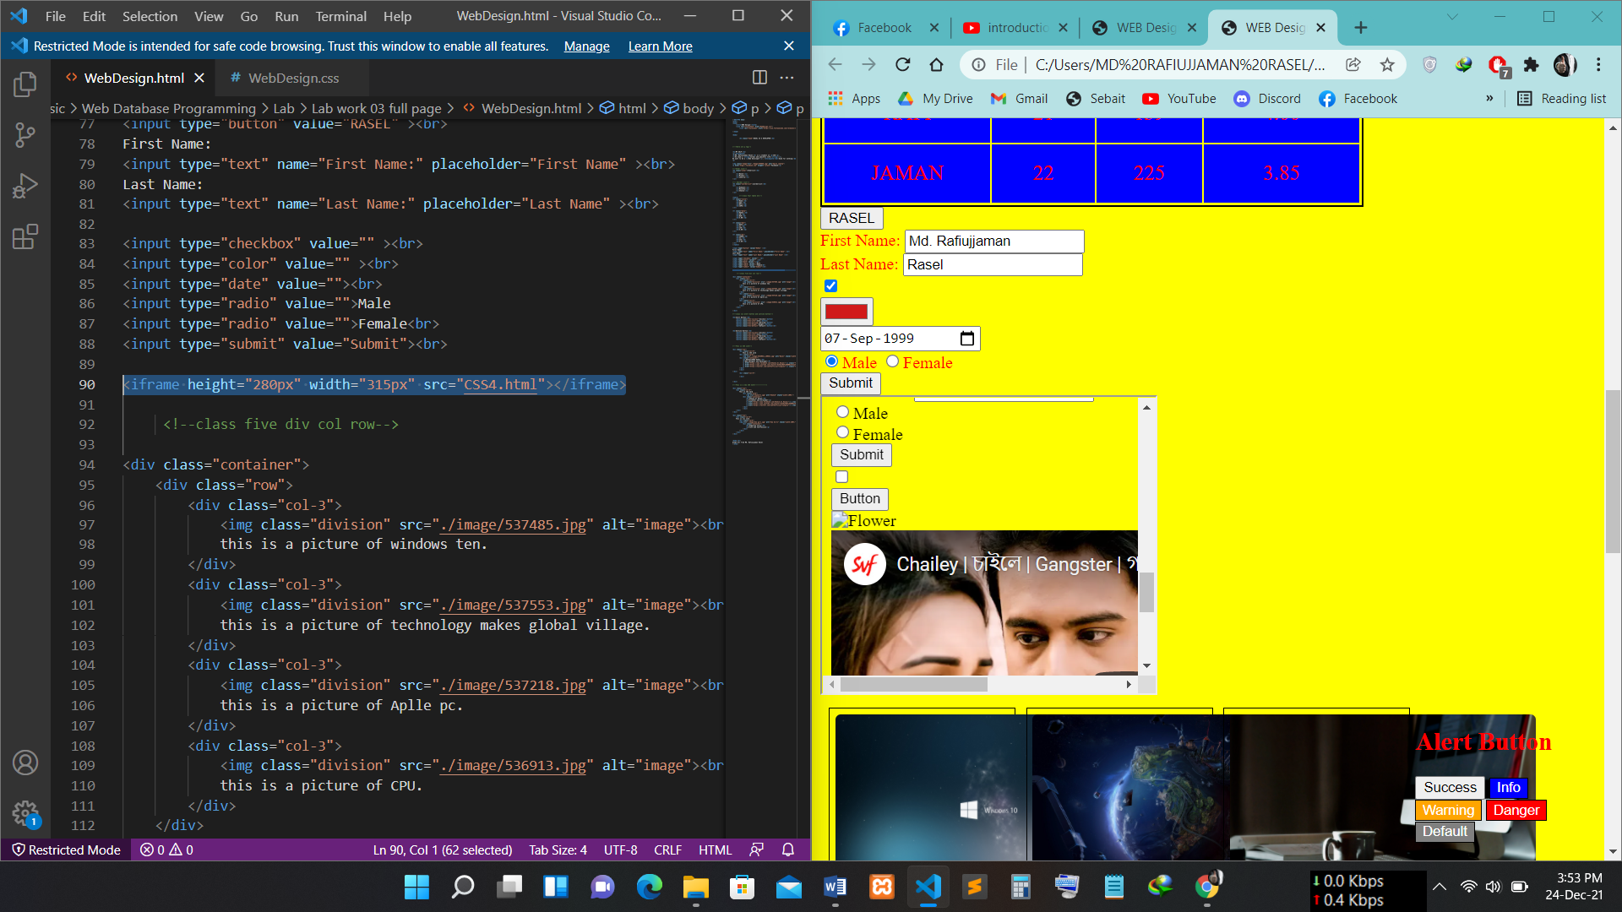

Add a iframe.

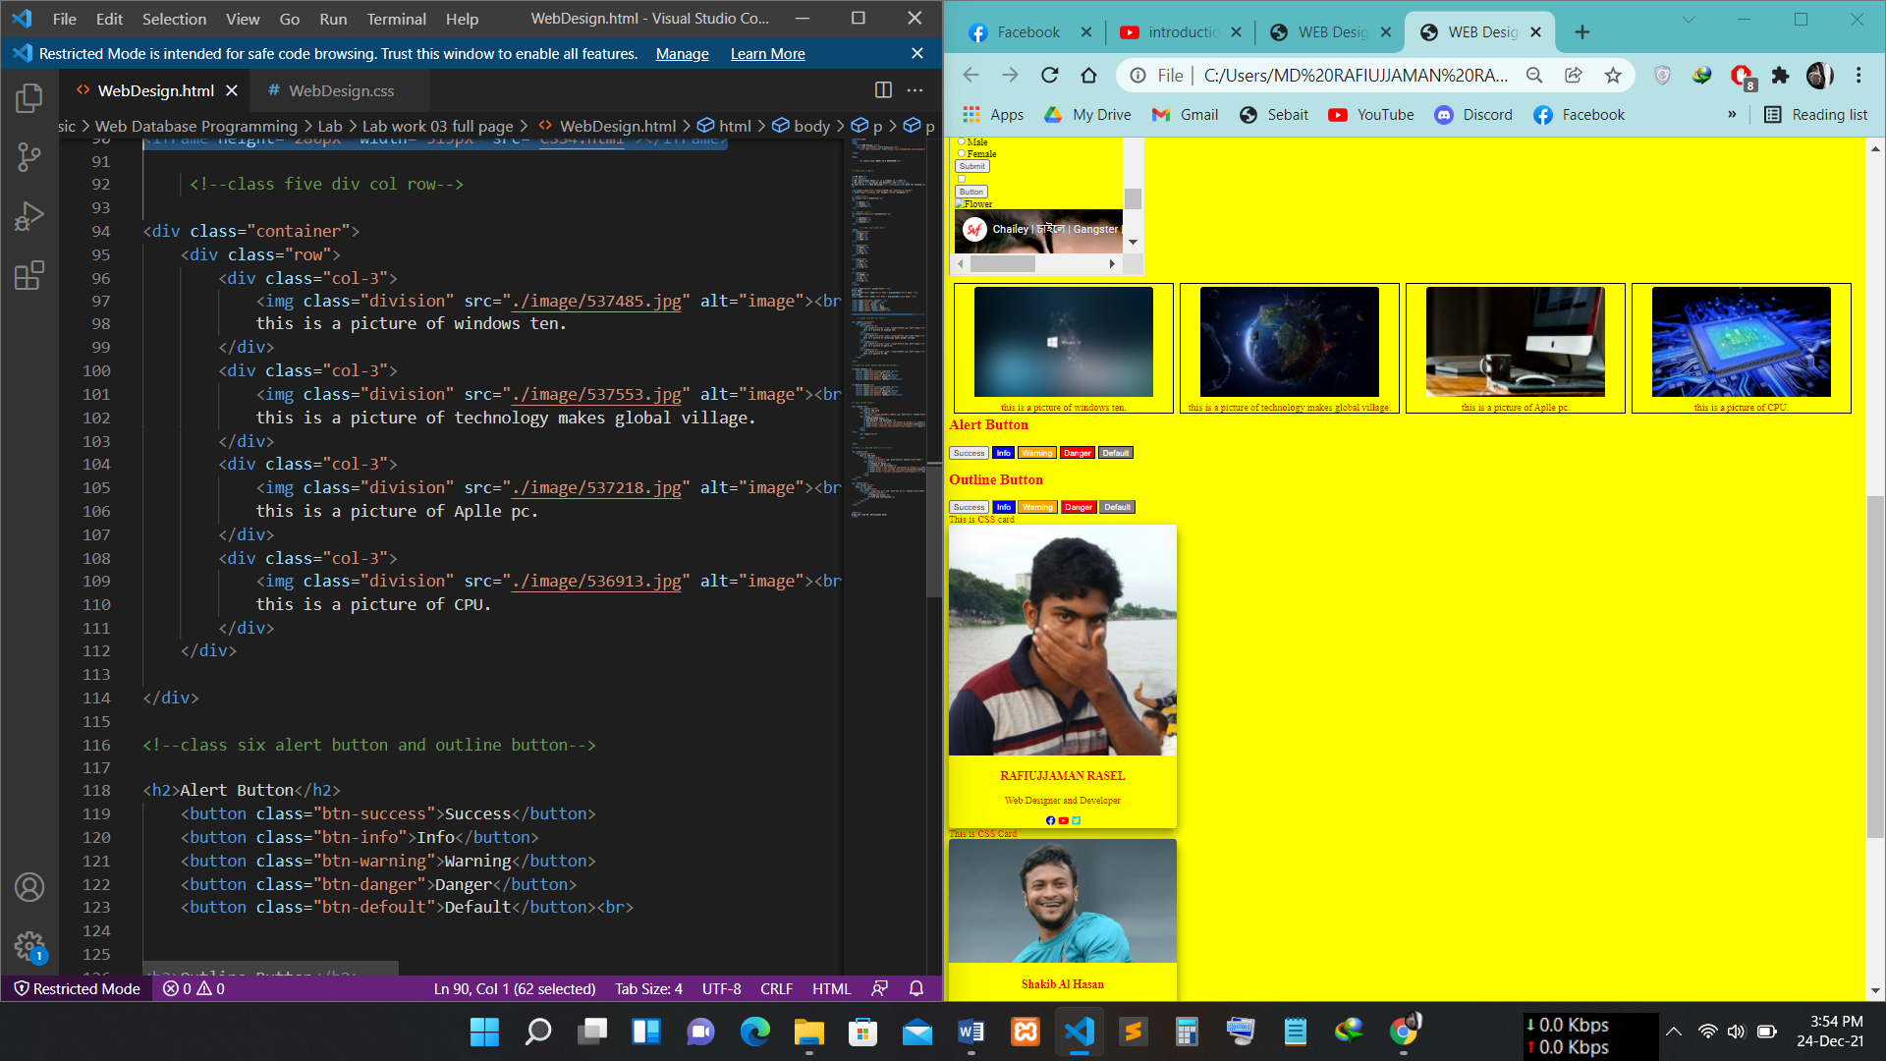

Give some information with photo and create some button.

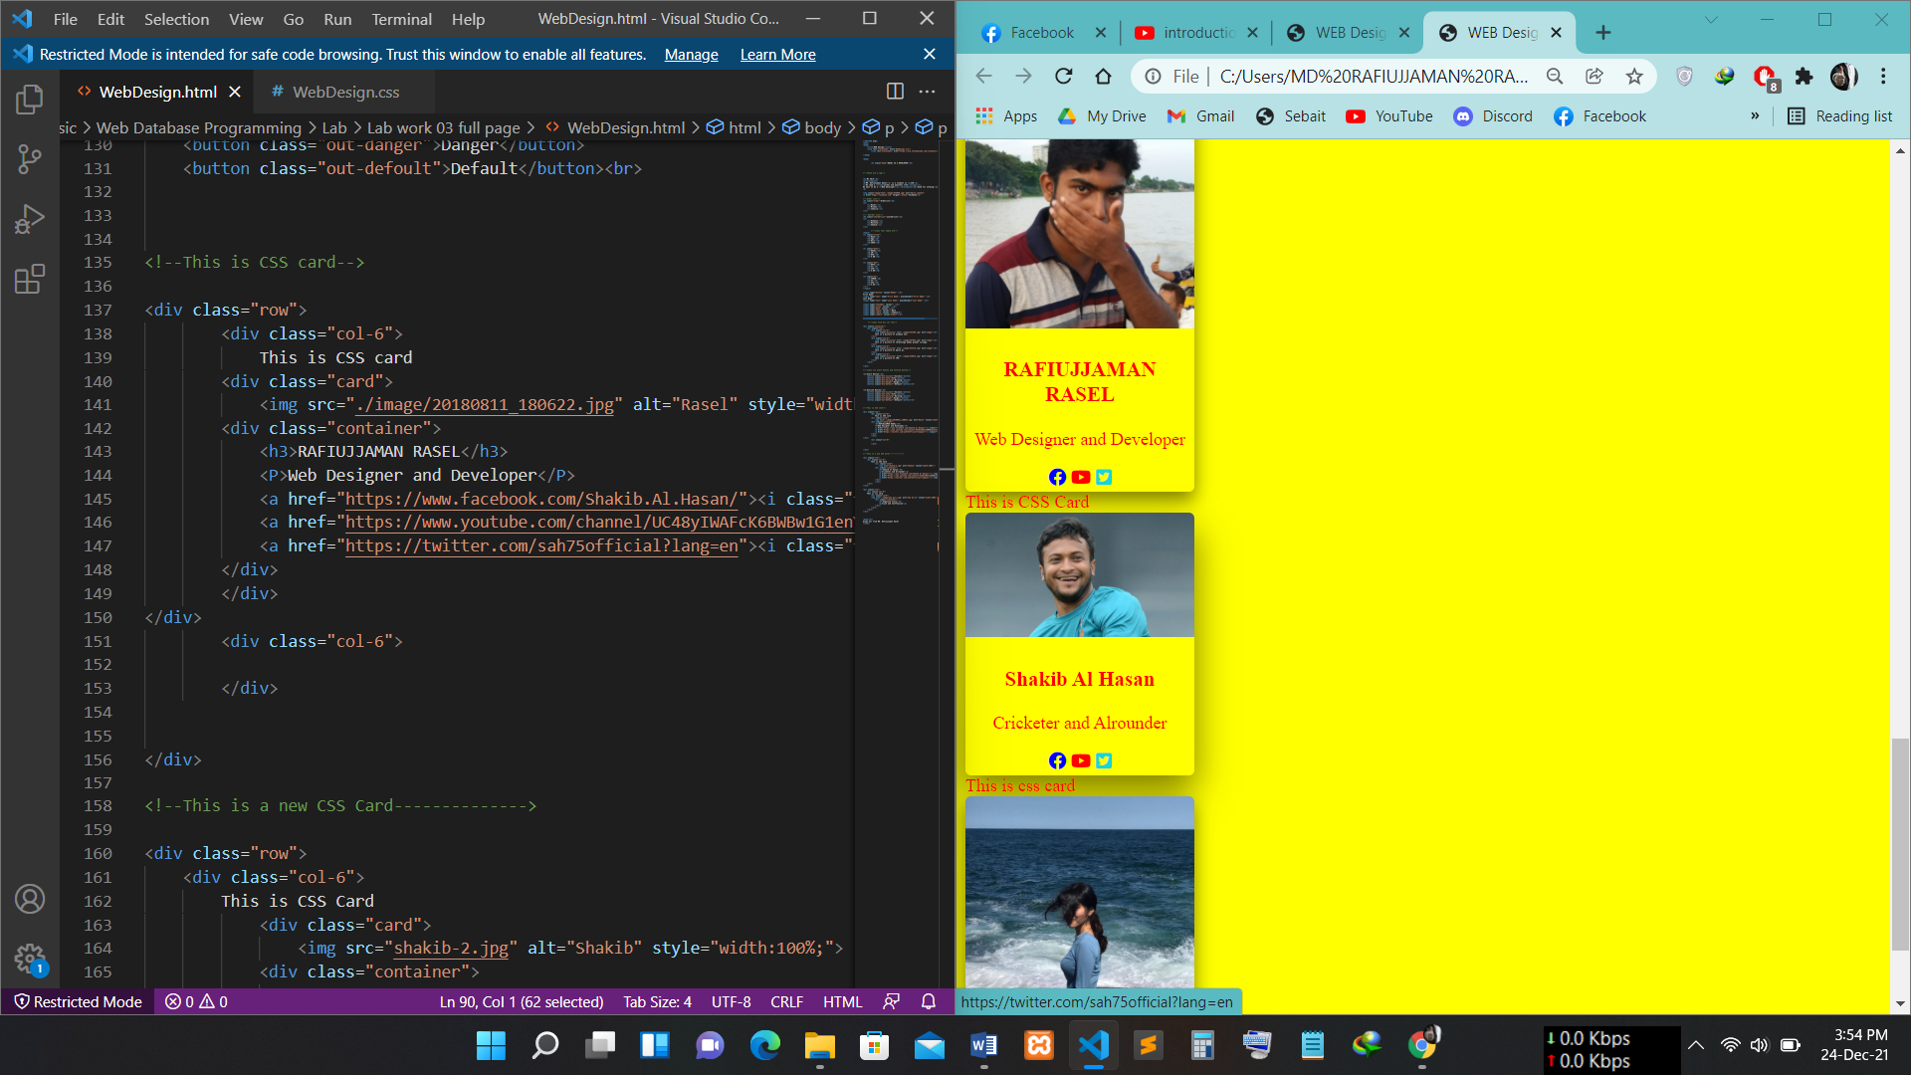

Create CSS card. And adding icon(fb, YouTube, twitter).

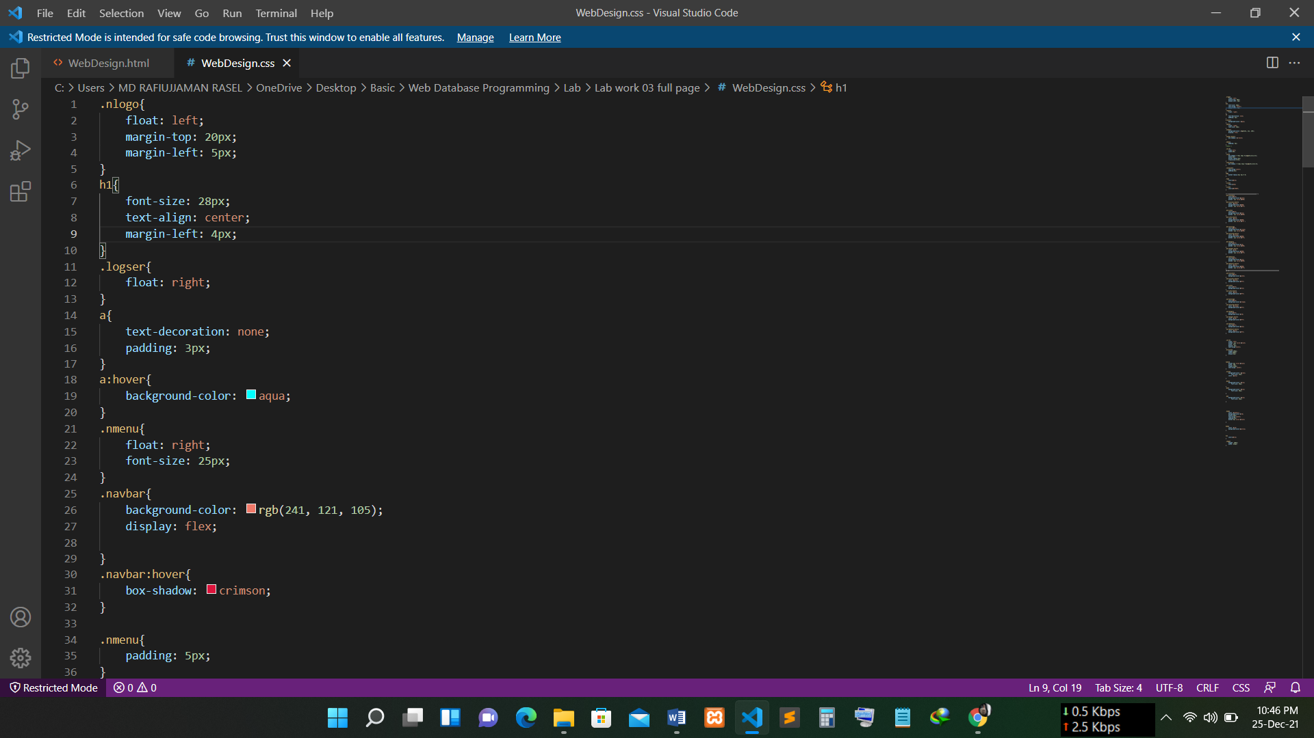

CSS Code SS: 1.1

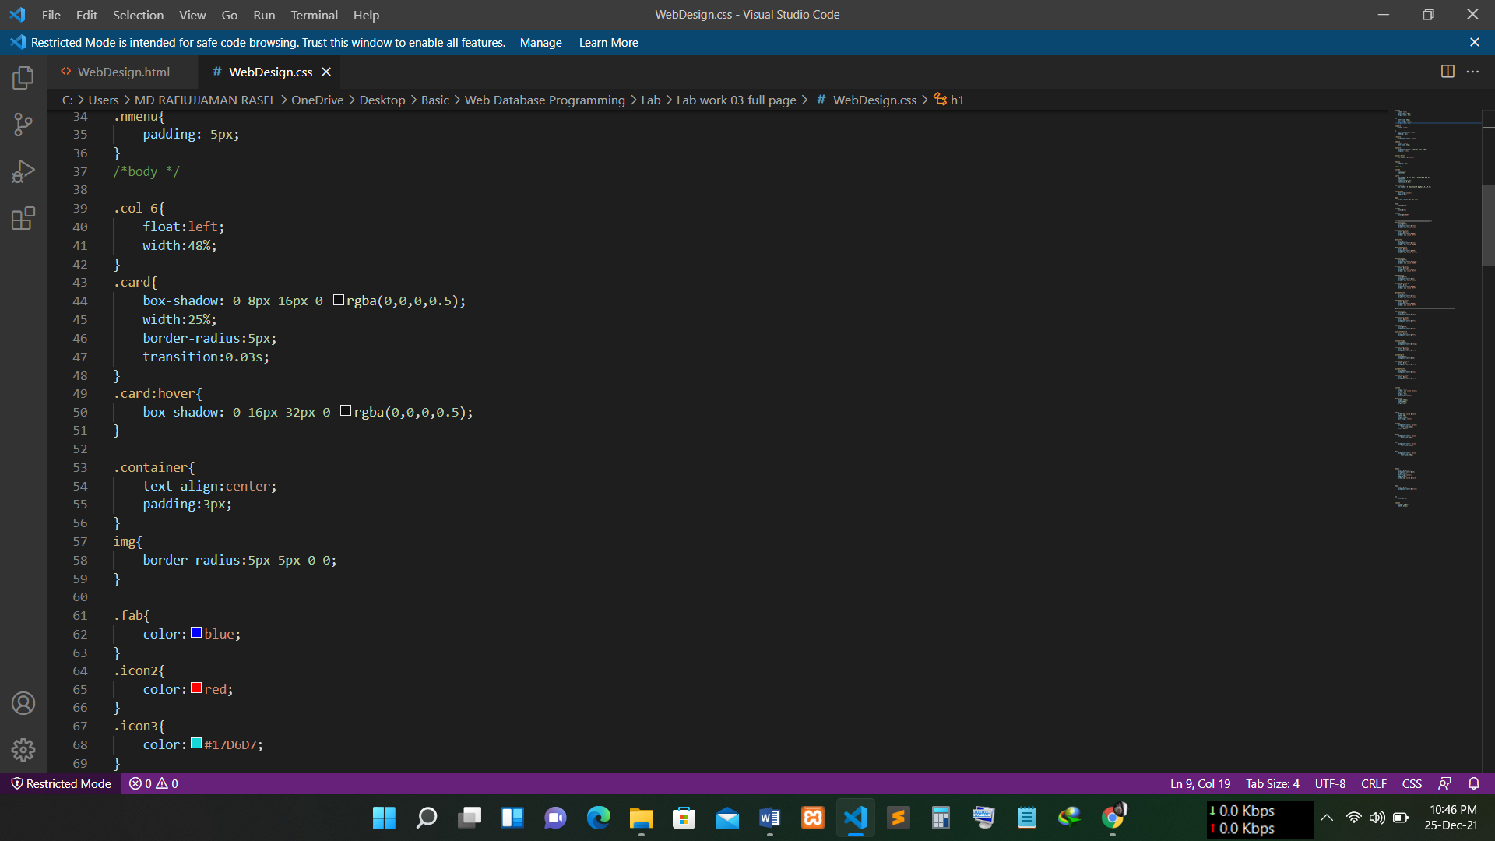

CSS Code SS: 1.2

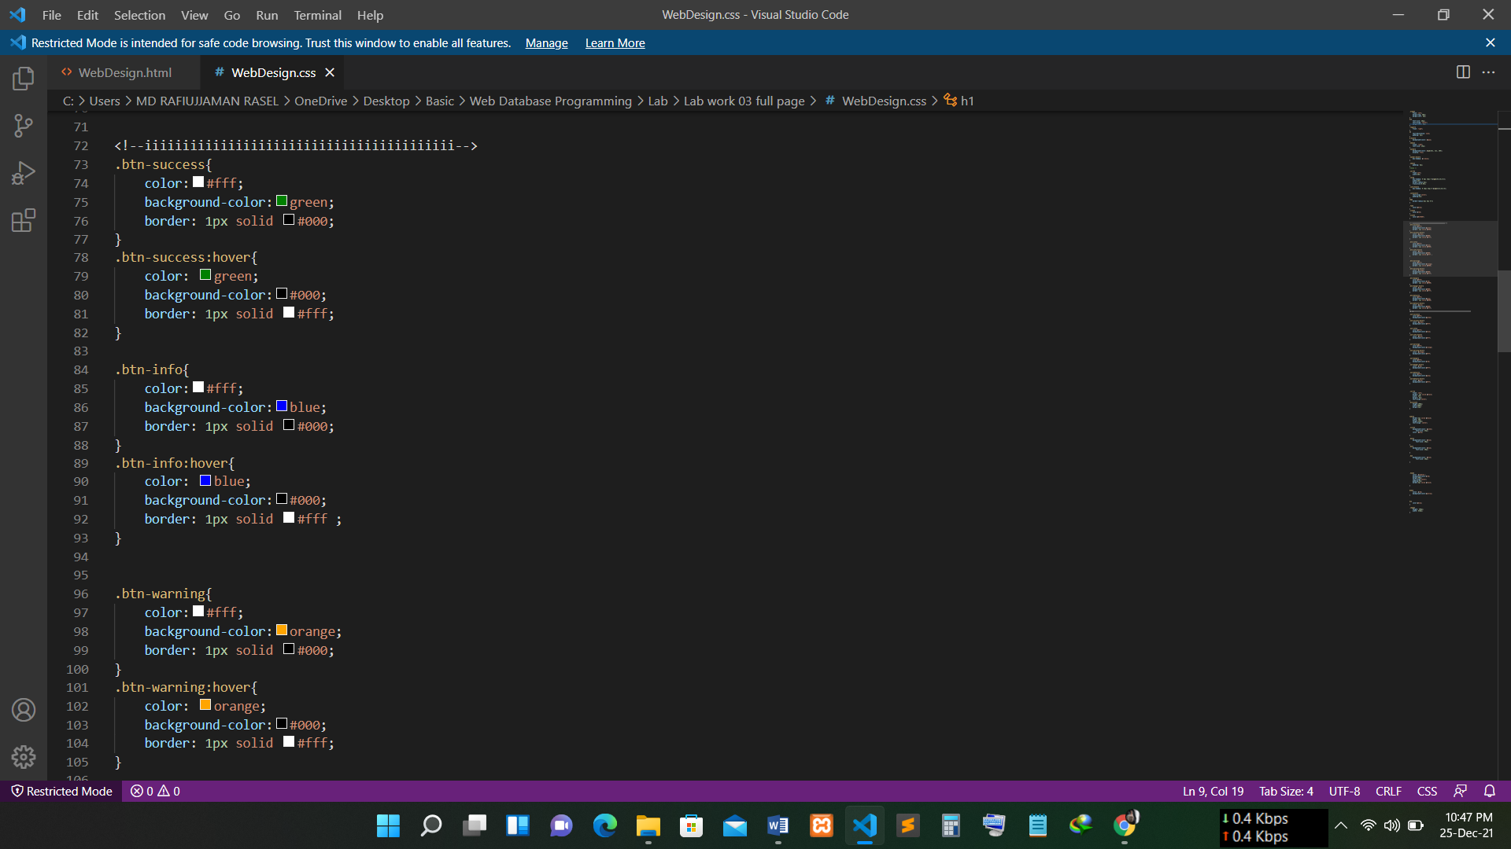

CSS Code SS: 1.3

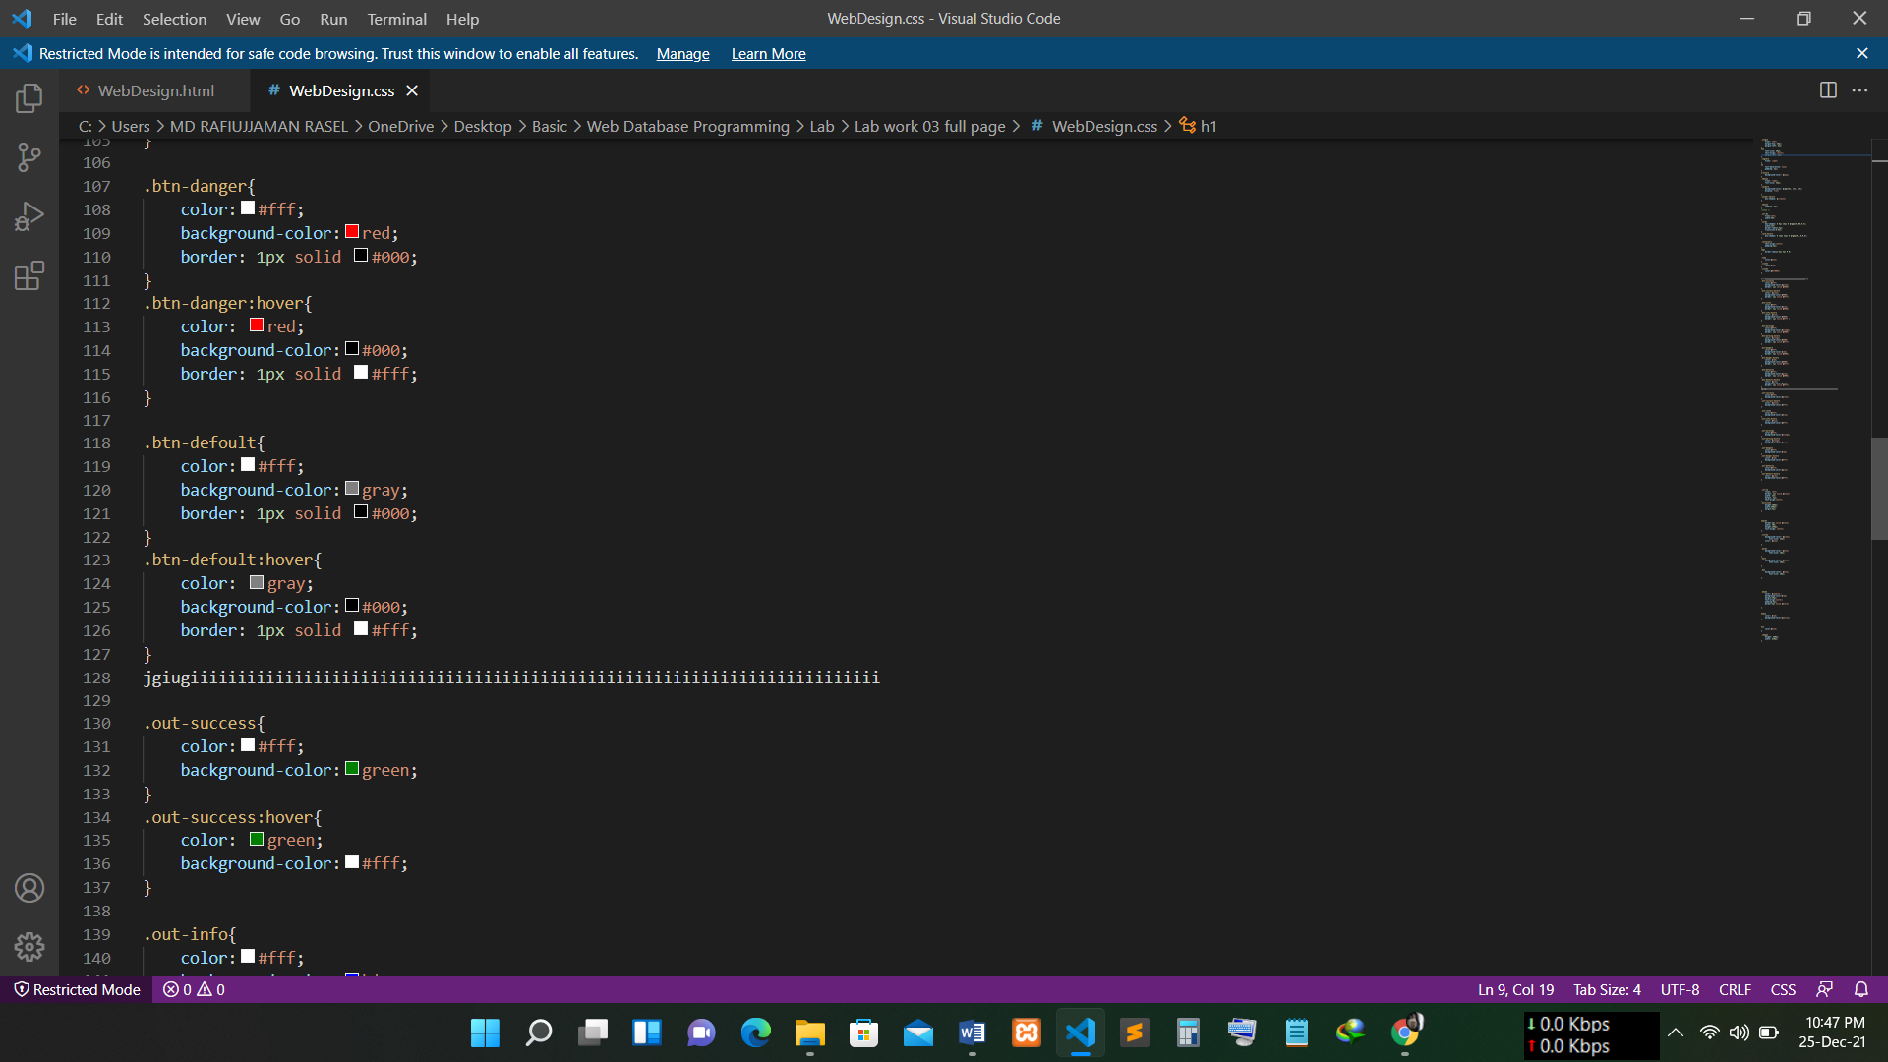

CSS Code SS: 1.4

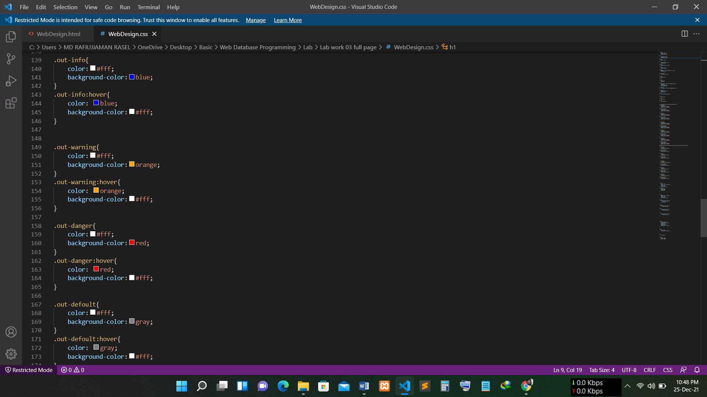

CSS Code SS: 1.5

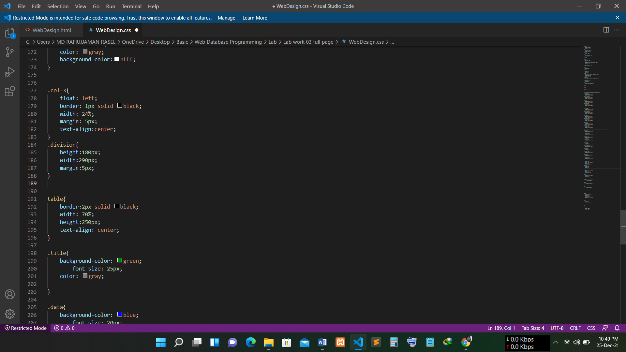

CSS Code SS: 1.6

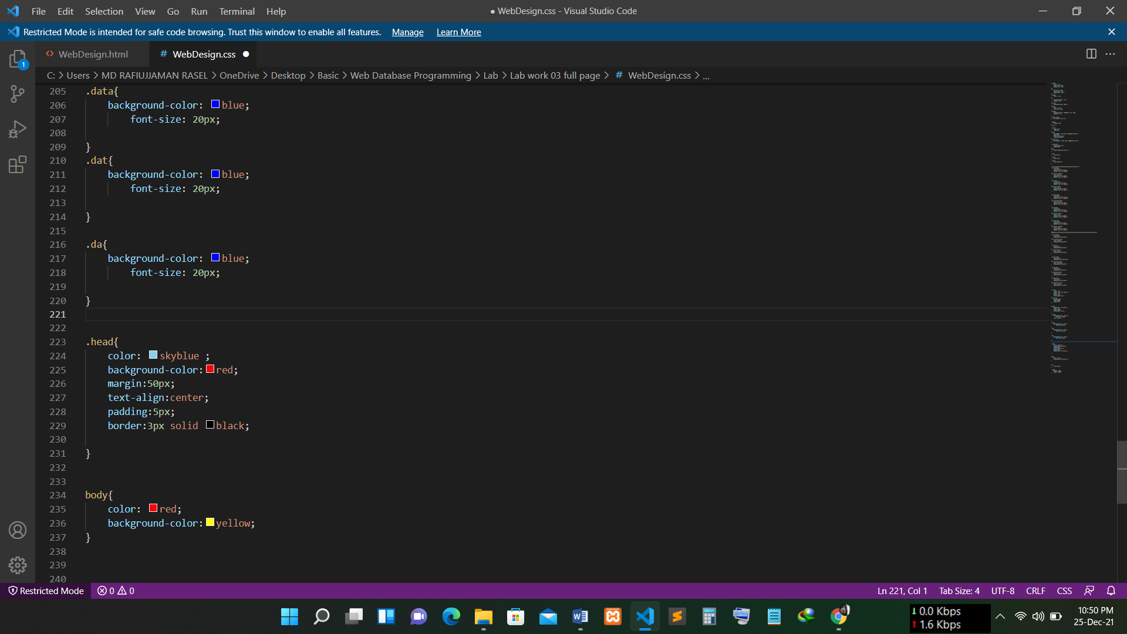

CSS Code SS: 1.7

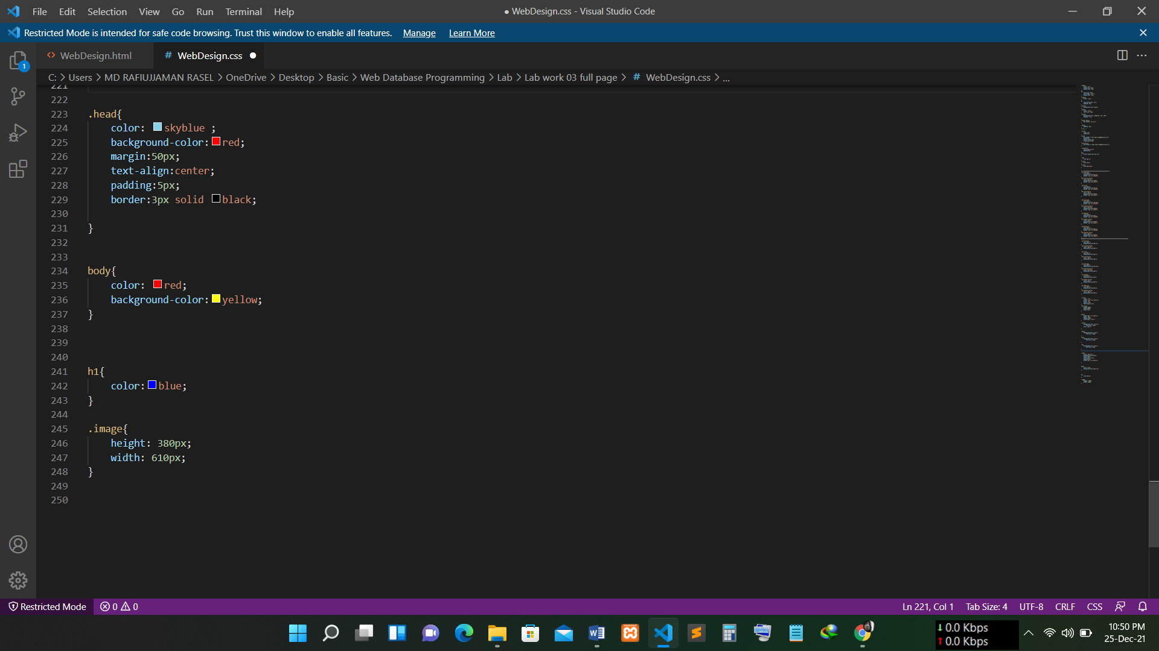

CSS Code SS: 1.8